DA No: 32/22

PAN: 186982

ADDRESS: 100-102 Walker Street North Sydney

PROPOSAL: Demolition of existing building and construction of a 48-storey commercial office tower with ancillary retail tenancies, basement car parking and (half) a publicly accessible pedestrian laneway.

DATE: 8 March 2022

ATTENDANCE:

Chair: Professor Peter Webber

Panel Members: Dave Tordoff, Peter St Clair

Council staff: Jim Davies

Applicant: Guy Lake & Jonathan Claridge, Bates Smart, Mark Hotson, Pro-invest, Nick Dillon, Tactical Group, Murray Donaldson & Eliza Scobie, Urbis

PANEL’S ADVICE

Principle 1: Context and local character
- Current & future context
- Of most relevance to the site is the proposed building at 110-122 Walker Street (DA 19/21, undetermined), immediately north of the site, which shares the proposed pedestrian laneway at the site’s northern boundary; and the commercial tower under construction at 86-88 Walker Street, immediately south of the subject land.
- Respectively these buildings’ heights are RL 270.3 and RL 232.6.
- The height of the proposed development is RL 239.

- Local character
- The building generally conforms with the emerging commercial character in North Sydney, with several other new office developments in the pipeline.

- Heritage
- There is no heritage directly relevant to the project.

Principle 2: Built form, scale and public domain/ urban design response
- Height, bulk and scale
  - Of relevance are the LEP’s height maxima and proposed heights of the subject development and the adjoining buildings (under construction and undetermined):
      - 88 Walker – RL227/RL 232.6
      - 100 Walker – RL 227/RL 239
      - 110 Walker – RL 260/RL 270.3
  - Of the three buildings, the approved building (No 88) was supported by a satisfactory request to breach the height limit. The proposal had a significant constraint being the fire station heritage item. 110 Walker has not been decided, although Council has recommended approval of the height breach to the Sydney North Planning Panel (supported by a request to contravene the standard).
  - Applicants for these projects argued the height breaches are justified, inter alia, by climbing up the hill in line with ground-level topography, thus creating a stepped skyline.
  - The panel considered that the height of the proposal relative to 88 Walker and 110 Walker appeared reasonable, however it was noted that the proposed height of 110 Walker was still under assessment. The future context is a key determining factor of appropriate height for this site. A reduction in height of 110 Walker may also require a reduction of height on the subject site.

- Street, side and rear setbacks
  - Proposed setbacks are detailed on the architectural plans and in the design report, by Bates Smart, architects. From this report, the following diagrams compare the building envelope mandated by the North Sydney LEP and DCP with that proposed:
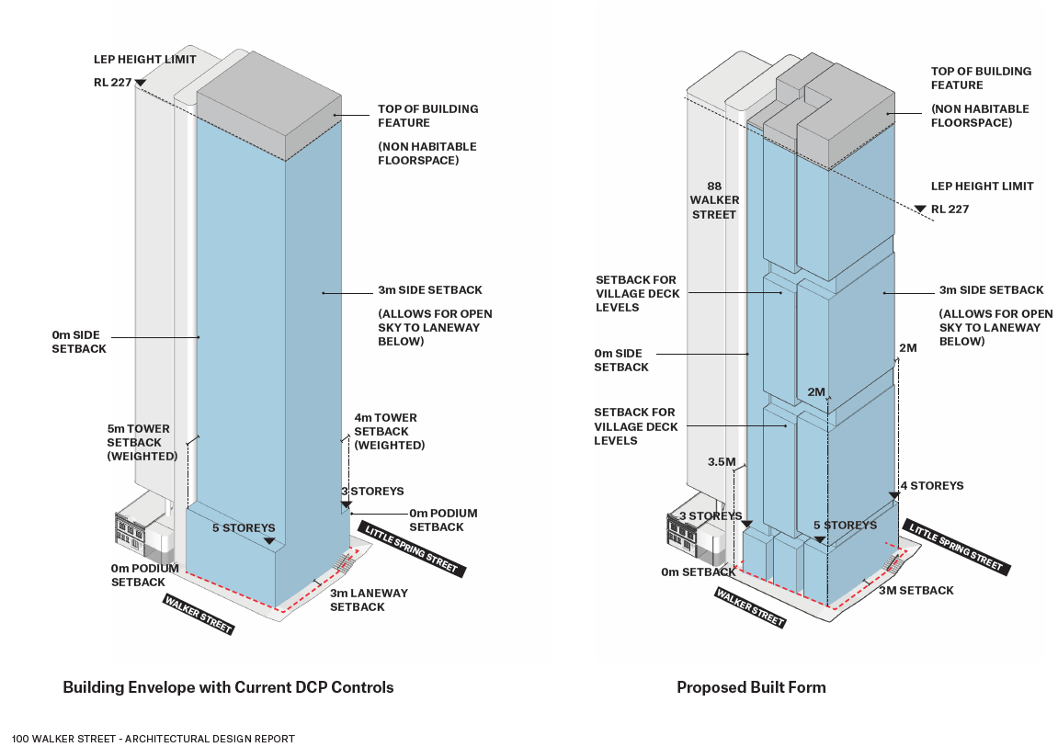

  - Regarding setbacks, the applicant submitted that:
  - The building envelope proposed was arrived at as a result of site analysis, environmental wind study and visual impact assessment,
  - The proposed and DCP envelopes were benchmarked and found to have similar performance in ameliorating wind impact, and
  - That proposed setbacks have little impact on the streetscape.
  - Panellists were of the opinion that the Walker Street setbacks should not exceed 110-122 Walker Street.
  - It was suggested that increasing the Walker Street setback could be enabled by decreasing the Little Spring Street setback, noting the building core of 110 Walker is on or close to this street’s boundary for a large portion of the proposed building envelope.
  - Regard should also be given to the setbacks from Little Spring Street demonstrated by 88 Walker Street.
  - Council advised that at the time of the meeting, detailed assessment had not concluded, and that further advice regarding this and other matters relevant to the application would be provided to the applicant.
  - The applicant is requested to provide details of how the weighted average setback has been calculated. This should also be compared to the weighted average calculation of 110-122 Walker Street.

- Building separation
  - There is no separation with No 88, both building’s cores being built to the common boundary.
  - With the pedestrian lane planned at the common edge of the subject site and 110 Walker, there will be 6.0m separation at podium level and 7.0m separation of towers (setbacks 100 Walker – 3.0m & 110 Walker – 4.0m).

- Public domain interface
  - Not discussed.
- Excavation and existing ground levels
  - Not discussed.

Principle 3: Density
- Proximity to transport, employment, services
- Locational advantages afforded by the site were again noted.
- Adjacent low/high density development
  - Relationships with adjoining development discussed above.
- Site sterilization/ site amalgamation
- The applicant noted the site was ‘isolated’, in that there is no opportunity to amalgamate with other sites.
- Site coverage, deep soil and landscape area
- Not relevant.

Principle 4: Sustainability, building performance and adaptability
- Energy efficiency initiatives
- The Panel commended the sustainability and passive solar design of the project, in particular the façade design which appears to be based on high quality analysis.
- Passive environmental design
- Examining the potential to introduce vertical shading to the western façade where shown by the modelling to be exposed, was suggested.

- Water management
- Proposed use of water storage for irrigation and stormwater detention were noted.

Principle 5: Landscape Integration
- Public domain
- That removal of an existing tree (or trees) from Walker Street, and that these should be replaced, were noted.
- Council’s Landscape Officer advised, regarding the withdrawn concept application, of the need to replace at a ratio of 2:1, any trees to be removed. Assessment regarding the current DA had not been provided at the time of the meeting.
- The relationship of street trees and proposed awnings was questioned.
- Communal open spaces
- Deep soil
- Planting on structures
- Maintenance
- Items b), c), d) and e) were not discussed.

Principle 6: Building configuration, planning, and amenity
- Configuration and planning
- The applicant advised alternative layouts of core and lettable space had been considered, noting site constraints and No88’s core location on the site’s southern boundary.
- The fire stairs are located in the south-western corner, to optimise the openness of the building to Little Spring Street, which was commended.
- Apartment size and layout
- Not relevant.
- Pedestrian access and entries
  - Again the panel concluded this to be a strength of the project, with the integration of levels throughout a highly-functioning ground plane.
- Awnings
- Awnings over the laneway and to the corner of the lane and Walker Street are too high to provide adequate weather protection.
- The applicant countered, stating the awning height location (up to 2 storey above ground level) ‘opened-up’ the upper ground level to interact with activities at lower ground level, the latter being at the same level as the pedestrian lane. The awning’s height at the Little Spring Street entrance also responded better to the steps down to the pedestrian link.
- The Panel appreciated the applicant’s latter point but considered that the awning should be lowered at the Walker Street end, and along the northern end of the Walker Street frontage, or the façade detailing could be amended to provide additional street level weather protection below the primary awning.
- The importance of co-ordination of awning heights with 110 Walker was agreed (although matching the heights was not necessary), however it was noted that replication of the awning on 110 Walker Street is not desirable.
- Glazed downturns at the ends of awnings should be considered, to improve weather protection.
- A complete covering to the lane was an option considered, although not applied in the design, noting 110 Walker approached the laneway differently, by maintaining openness to the sky. The critical issue is for the design of the laneway awnings for both properties to be integrated to ensure that the outcome is attractive and provides good protection for pedestrians from rain and wind.
- Common circulation
- Discussed above, in relation to publicly accessible levels of the building.
- Communal spaces
- Provision of various types of spaces for different activities is considered a commendable aspect of the development, at public domain levels and at various levels of the building.
- Private open space and balconies
- Ceiling heights
- Subterranean spaces and excavation
- Ground floor/podium level apartments
- Roof design
- Vehicle access and parking
- Waste management
- Ancillary spaces
- Utilities/ Building services
- Visual Privacy
- Acoustic Privacy
- Items g) to q) are either not relevant or were not discussed.
- Solar and daylight access
- The Panel opined that good solar access into the building could be further detailed and possibly aid in supporting the case for reduced setbacks, as proposed. Studies of sample floors indicating the level of daylighting achieved to the centre of the floor plates would be helpful.
- Natural cross ventilation and natural ventilation
- Natural ventilation of spaces within the building was strongly supported.
- Southern-eastern corners of a number of levels will enable natural ventilation, via the use of louvres, without interfering with air-conditioning of remaining spaces on these levels, which would be sealed. The applicant anticipates the majority of tenants may incorporate this natural ventilation option within their floors.
- The applicant also aims to make the podium a ‘mixed mode’ area.
- Shadow impacts
- The applicant demonstrated that the development complies with LEP requirements to maintain sunlight to designated “special areas” in the CBD and to not significantly increase overshadowing of public open space and residential zoned land adjacent to the CBD.
- View impacts
- Not discussed.
- Noise and natural ventilation
- Noise was not discussed, ventilation is discussed at item s), above.

Principle 7: Safety
- Entry and security
- Informal surveillance
- These items were not discussed.

Principle 8: Housing diversity and social interaction
- Not relevant to the proposed commercial building.

Principle 9: Architectural expression and materiality
- Material palette
- Composition and scale
- Maintenance
- Detailing/Buildability
- Parapet and rooftop plant screening
- Although the items listed under this principle were not discussed individually, the Panel complimented the development’s architectural expression and use of materials. Greater warmth in relation to colour and tone than the dark greys indicated on the images, is recommended.

Recommendations to Achieve Design Excellence

The Panel supports the proposal, subject to the identified issues being resolved, as recommended above.

Development Services Manager’s Note

The outcome of this review by the Design Excellence Panel is not determinative and is but one of many inputs into the assessment process. Applicants are urged to have high regard to the panels input and respond accordingly.

